Homeopathy: A Healing Hand for Cancer Patients | - Los Angeles School of Homeopathy  - Presents
We are excited to have Jason-Aeric Huenecke guide us on an exploration of current theory, methodology, and practices in homeopathy cancer care. He will present therapeutic options using existing remedies and show how some newly proven remedies can make an impact. Jason-Aeric will demonstration—through case studies, how individualized homeopathic care stimulates the vital force and empowers clients as they navigate the cancer terrain. Jason-Aeric will not only discuss strategies for working with allopathic practitioners, but he will also discuss how to work with those clients whom have chosen for forego traditional allopathic treatment. Jason-Aeric will also help provide options for those in advanced disease states as well as how to traverse end of life care for your clients and their families.  For questions contact LA School of Homeopathy:  Phone: 310 279-5016  Fax: 310 279-5019  info@lahomeopathicschool.com | 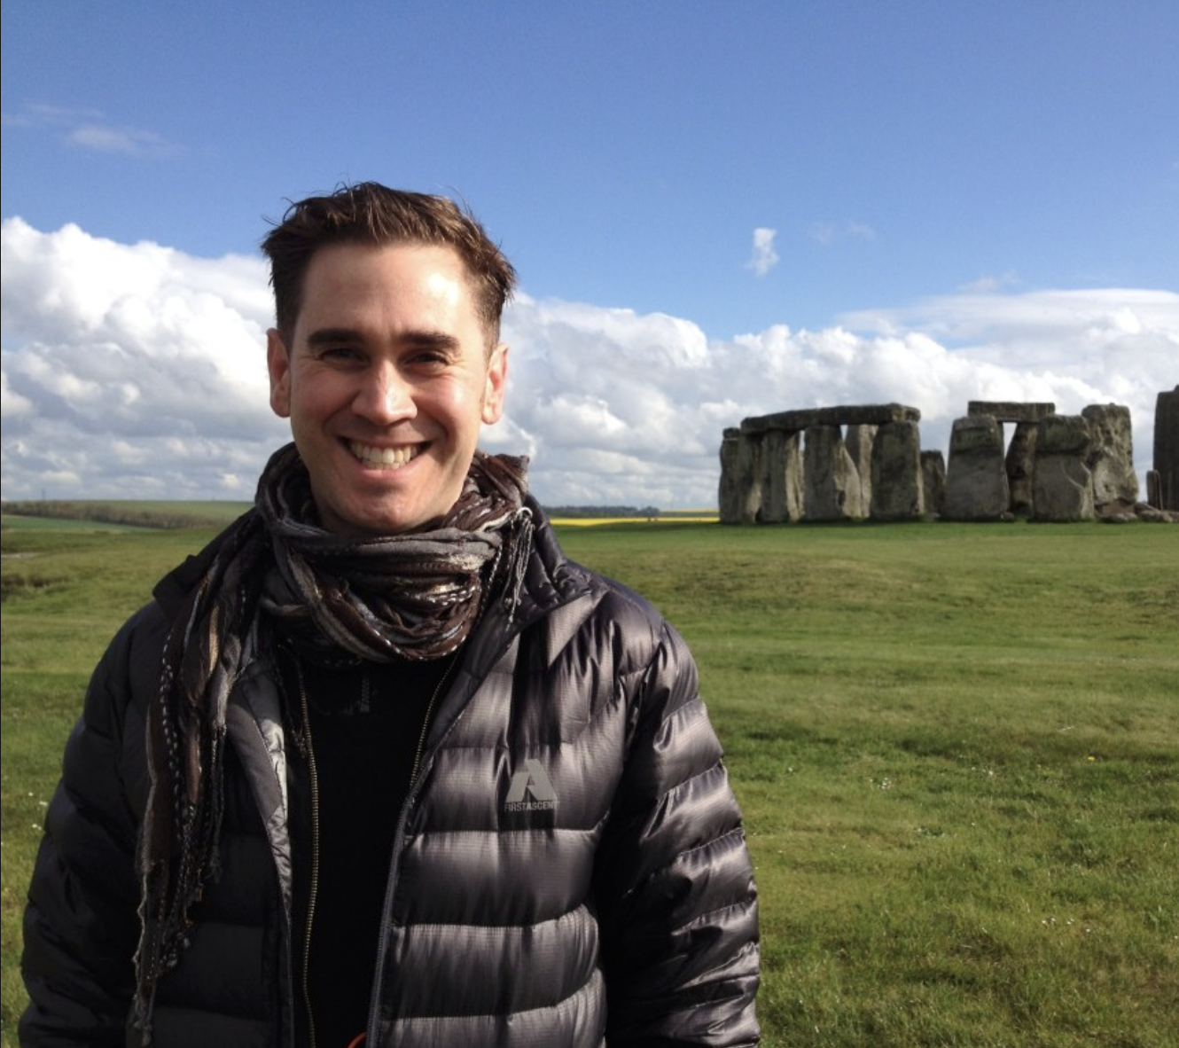Jason-Aeric Huenecke  CCH, RSHom (NA)  DATE AND TIME  February 10-11, 2018  Saturday and Sunday  9:00am - 5:00pm  LOCATION  Yo-San University  13315 West Washington Blvd.  Los Angeles CA 90066  COST  Before February 1st $285  After February 1st $355
SEATING IS LIMITED…REGISTER TODAY!

